**Week 3:**

Implement a "Hotel Booking System" using C++ with OOP principles.

Deliver:

* C++ application that allows users to book, cancel, and view hotel rooms.
* Store and retrieve booking data.
* Code repository with build instructions and sample test cases.
* Execution screenshot along with logs.

Code Repository: <https://github.com/Akriti987/Weekly_Tasks.git>

**Execution Documentation for C++ Hotel-Booking System**

This document describes a C++ application implementing a basic Hotel Booking System using Object-Oriented Programming (OOP) principles.

This project aims to create a simple command-line interface for users to:

* View available hotel rooms.
* Book a room.
* Cancel an existing booking.
* View booking history from ‘booking.txt’ file.

**1. Build Instructions**

1. Save the code as **hotel_booking_system.cpp**
2. Compile the code using a C++ compiler

**2. Running the Application:**

* **Compile the code using a C++ compiler:**

g++ hotel_booking_system.cpp -o hotel_booking_system

* **Run the executable:**

./hotel_booking_system

**3. Sample Test Cases**

* **Test Case 1:**
  + Display available rooms.
  + Book a room for a guest.
  + Verify that the room is no longer available.
* **Test Case 2:**
  + Book a room for a guest.
  + Cancel the booking.
  + Verify that the room is now available again.
* **Test Case 3:**
  + Attempt to book a room that is already booked.
  + Verify that the booking fails.
* **Test Case 4:**
  + Load bookings from file, display bookings, and save updated bookings to file.

**4.Execution Screenshots:**

🡪Display available rooms

🡪Book a room

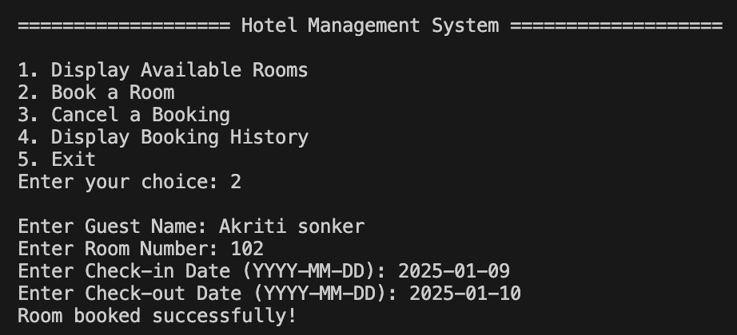

🡪Available rooms

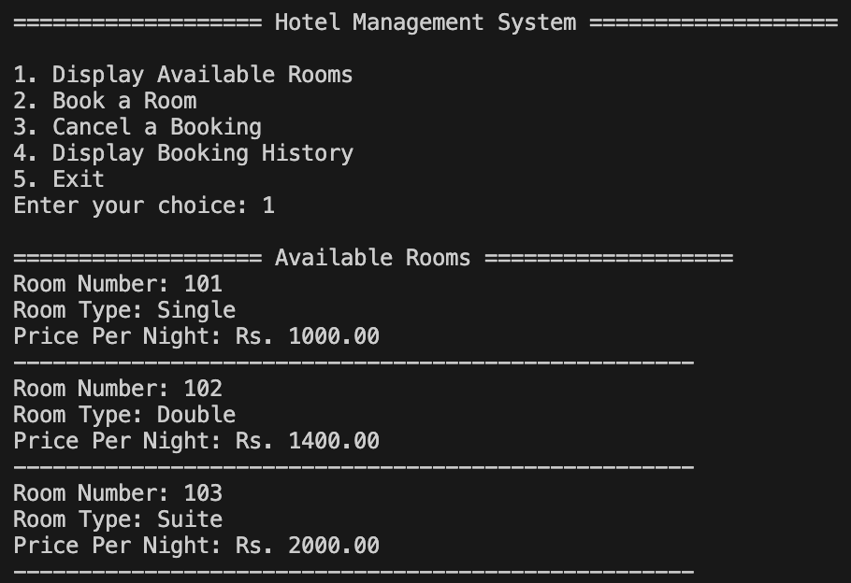

🡪Booking History

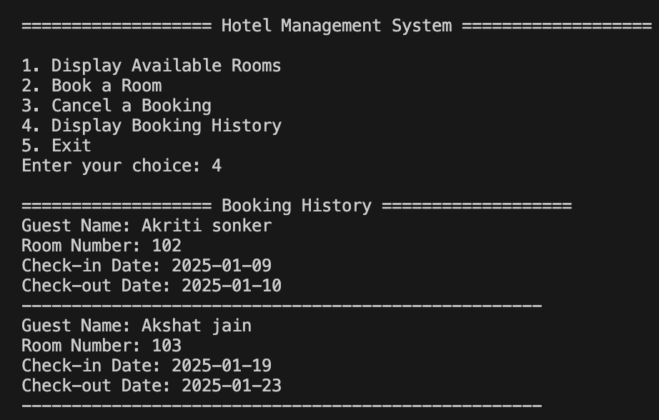

🡪Cancel Booking

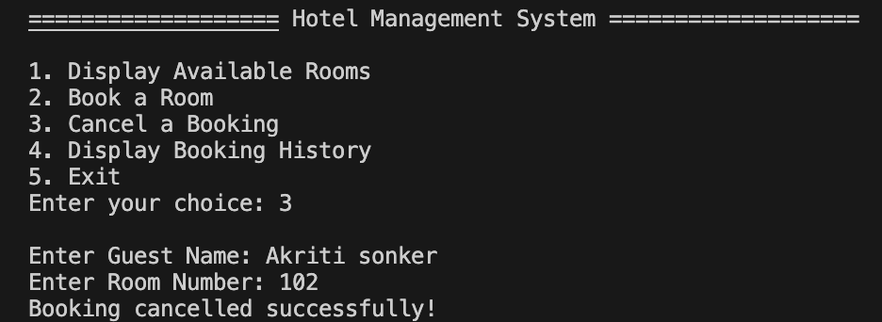

🡪 Booking History after cancelling current booking

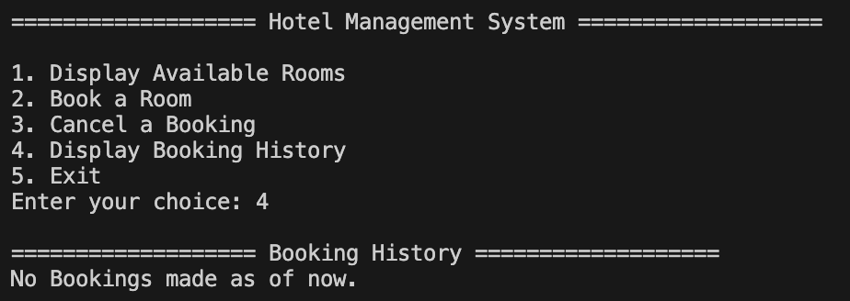

🡪Saving the bookings in ‘bookings.txt’ file

🡪 Exit

**5.Code Snippet**

